**Super Resolution of Land Cover Mapping  
(Image Processing)**

P.NAVEEN RAJ 2009115061

S.B.YUVARAJA 2009115118

YASWANTH KUMAR 2009115117

**PROJECT GUIDE - DR.K.VANI, ASSOCIATE PROFESSOR, DEPT OF IST, ANNA UNIVERSITY**

**SIGNATURE :**

**INTRODUCTION :**

Satellite images are used for preparing latest land cover maps. Maps are prepared through classification.

* **Hard classification** is mapping of the one pixel to one class approximately.
* **Soft classification** is finding of percentage of spectral components in the particular pixel.

**Super Resolution Mapping** is the technique that is used to map the identified spectral components in a particular pixel.

**ISSUES IN EXISTING SYSTEMS :**

Satellite images having lesser resolution will provide land cover mapping with poor accuracy . Using hard classification mixed pixel can be mapped to only one class.



**SOLUTION :**

Usually one pixel may contain mixed information so Soft Classification is preferred. Soft classification is a technique to predict proportions of land cover classes within mixed pixels using spectral un mixing. Super resolution mapping is a technique to predict spatial locations of land cover classes within mixed pixels in remotely sensed imagery using the sub pixel mapping(SPM).

For the SPM we use two step approach two-step approach

* first estimates fraction images by spectral un mixing.
* inputs fraction images into an SPM algorithm to generate the final sub pixel land cover map.

**LITERATURE SURVEY :**

***Subpixel Land Cover Mapping by Integrating Spectral and Spatial Information of Remotely Sensed Imagery***

**-Feng Ling, Yun Du, Fei Xiao, and Xiaodong Li**

Main aim of this work is to retrieve final sub pixel land cover map from the remotely sensed image.

* Linear un-mixing model (LUM) is used for spectral un-mixing.
* Maximal spatial dependence model is adopted for SPM.

Spectral and spatial goal functions are combined to form a single optimization function.

**Min E ( r )= Espectral( r )+λ Espatial( r )**

**LIMITATION :**

* Co-Relation between pixel’s are not considered.
* Attraction between the classes with in the pixel is not consisdered.

***Super-resolution land cover pattern prediction using a Hopfield neural network***

**-Quang Minh Nguyen, Peter M. Atkinson & Hugh G. Lewis**

Super Resolution Mapping with **Hopfield Neural Network** using the soft classified proportions is used. PAN and MS images are processed and compared to find spatial dependence.

**OBJECTIVE:**

Soft Classification of image :

* Spectral components of various classes are identified
* Area proportion of various class is identified

Super Resolution Mapping :

* Spatial dependence is realized in simple and effective way using attraction and Co-Relation

**ALGORITHM:**

* Sub divide the pixel
* Allocate the classes randomly according to the area proportion.
* Calculate the attraction and correlation between the sub pixels
* Applying PSO algorithm for all proportion images.
* Integrate the classification map for all classes.

Final SRM map will be obtained

**SYSTEM ARCHITECTURE:**

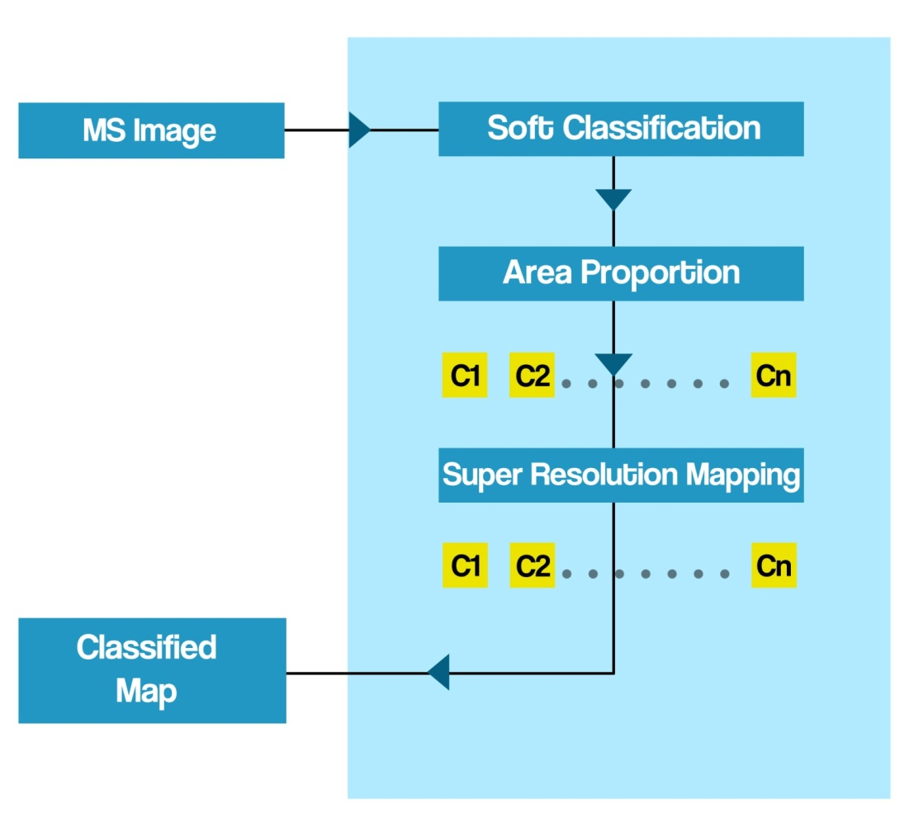

**ARCHITECTURE –SOFT CLASSIFICATION :**

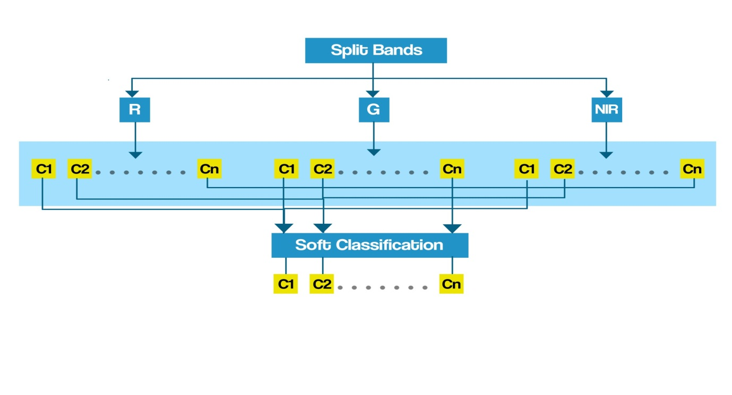

**Technologies/Tools Required :**

|  |  |
| --- | --- |
| **Requirement** | **Technology** |
| Operating System | Microsoft Windows 7 |
| Programming Language | MATLAB |
| Integrated Development Environment | MATLAB R2009a |

**Module Description: (With Split-Up For Each Member)**

|  |  |
| --- | --- |
| **Naveen Raj** | 1. **Identifying classes**  * **Different classes that are to be found are identified** |
| 2 . Spectral un mixing in G band   * **Proportion of various classes in G band is found** |
| 3 . Identifying co-relation between the sub pixels   * **Co-relation between the nearest sub pixel is found** |

|  |  |
| --- | --- |
| **Yuvaraja** | 1. **Splitting up of bands**  * **Images in R band , G band , NIR band are identified.** |
| 2 . Spectral un mixing in NIR band   * **Proportion of various classes in NIR band is found** |
| 3 . Identifying attraction between sub pixels   * **Cor-relation between the nearest sub pixel is found** |

|  |  |
| --- | --- |
| **Yaswanth** | 1. **Spectral Un Mixing in R band**  * **Proportion of various classes in R band is found** |
| 2 . Merging of classes   * **Various band matrix’s are combined and for each class matrix is formed** |
| 3 . Applying PSO to obtain final result |

**Time Chart (With Expected Outcome):**

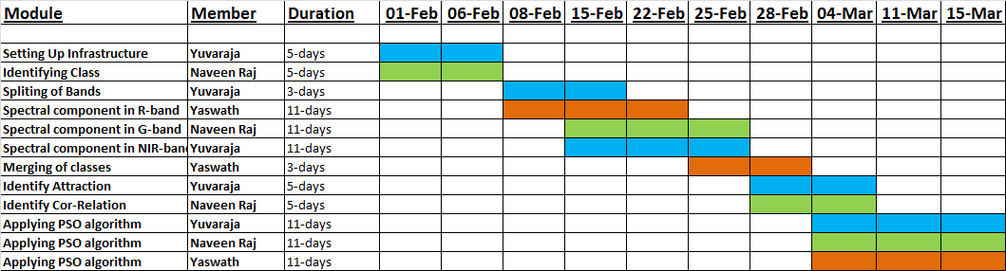

**References:**

* J. Tatem, H. G. Lewis, P. M. Atkinson, and M. S. Nixon, “Super-resolution land cover pattern prediction using a Hopfield neural network,” Remote Sens. Environ. , vol. 79, no. 1, pp. 1–14, Jan. 2002
* Feng Ling, Yun Du, Fei Xiao, and Xiaodong Li“Subpixel Land Cover Mapping by Integrating Spectral and Spatial Information of Remotely Sensed Imagery” IEEE GEOSCIENCE AND REMOTE SENSING LETTERS., 2011 IEEE
* P. M. Atkinson, “Issues of uncertainty in super-resolution m apping and their implications for the design of an inter-comparison study,” Int. J.Remote Sens., vol. 30, no. 20, pp. 5293–5308, Oct. 2009
* J. Tatem, H. G. Lewis, P. M. Atkinson, and M. S. Nixon, “Super-resolution target identification from r emotely sensed images using a Hop-field neural network,” IEEE Trans. Geosci. Remote Sens. , vol. 39, no. 4, pp. 781–796, Apr. 2001